**Insert Queries:**

INSERT INTO AIRPLANE1_table VALUES ('AP323344','AIR1','2011-02-21'),('AP432379','AIR2','2012-03-22'),

('AP241175','BOE3','2012-02-20'),('AP137783','AIR1','2012-04-16'),('AP100772','AIR1','2012-06-07'),('AP132221','AIR2','2010-07-04'),('AP107207','BOE2','2012-07-29'),('AP461923','BOE1','2012-07-31'),('AP913157','BOE3','2012-10-12'),('AP133451','BOE1','2011-09-22'),('AP813701','AIR1','2013-01-03'),('AP479451','BOE3','2012-01-13'),('AP132984','AIR2','2013-11-28');

INSERT INTO FLIGHTS_ROUTE1_table VALUES ('4375','IAD','JFK','06:00','07:03'),

('1307','SFO','LGA','00:20','07:40'),('3019','ORD','LAX','14:40','18:15'),

('1436','LAX','BOS','10:05','15:33'),('7192','SYR','MIA','11:30','12:45'), ('2533','JFK','DCA','07:20','13:30');

INSERT INTO FLIGHTSCHEDULE12_table VALUES ('4375','2015-02-14','D','AP132984','06:30','07:40'),

('1307','2014-12-15','C','AP133451',NULL,NULL),('1307','2014-12-16','D','AP137783',NULL,NULL),

('3019','2015-01-16','O','AP432379',NULL,NULL),('2533','2015-01-16','O','AP133451',NULL,NULL),

('4375','2014-12-16','D','AP132221','06:30','07:40'),('7192','2015-01-17','O','AP100772',NULL,NULL),

('7192','2014-12-18','O','AP107207',NULL,NULL);

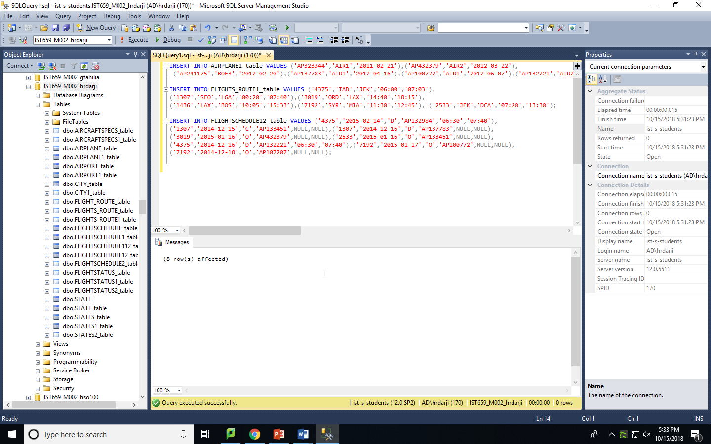

**QUESTIONS**

1. Find out all flight schedule information of flight “3310” and “3312”. Make sure to show all the fields.

**SQL QUERY:**

SELECT * FROM FLIGHTSCHEDULE12_table

WHERE flightNumber=3310 OR flightNumber=3312;

**SCREENSHOT:**

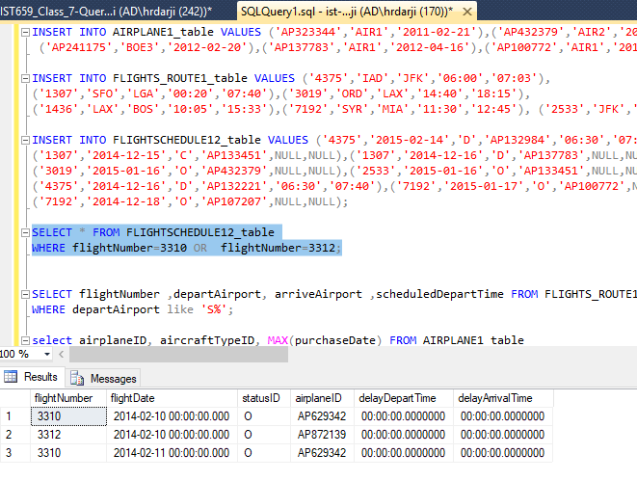

1. Find all flights departing from airports that start with ‘S’. Show flight number, depart airport, arrival airport, and depart time.

**SQL QUERY**:

SELECT flightNumber ,departAirport, arriveAirport ,scheduledDepartTime FROM FLIGHTS_ROUTE1_table

WHERE departAirport like 'S%';

**SCREENSHOT:**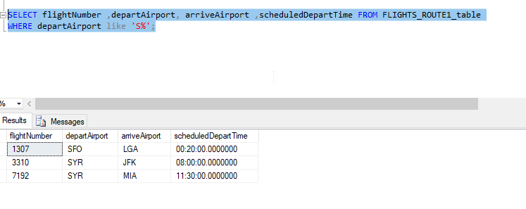

1. Find 4 most recently purchased planes. Show airplane ID and purchase date only.

**SQL QUERY:**

SELECT top 4 airplaneID,purchaseDate

from AIRPLANE1_table

where purchaseDate<=

(

Select max(purchaseDate)

from AIRPLANE1_table

)

order by purchaseDate desc;

**SCREENSHOT:**

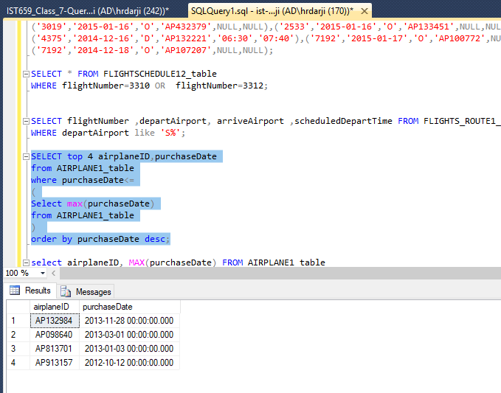

1. Count the number of flights departing each day. Show the date and the number of flights.

**SQL QUERY**:

SELECT flightDate, count(*) AS number_of_flights FROM FLIGHTSCHEDULE12_table

group by flightDate;

**SCREENSHOT:**

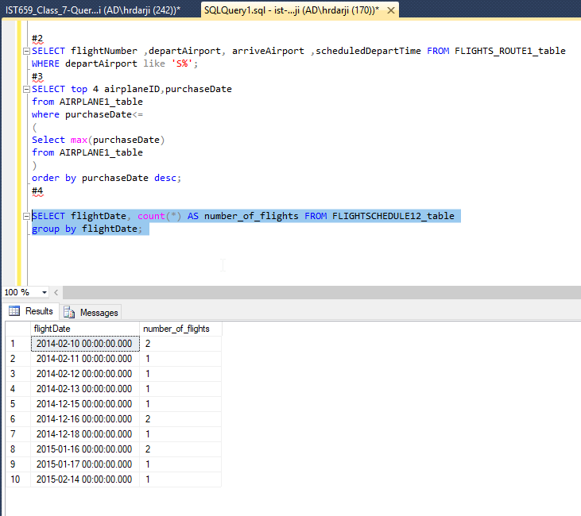

1. Sort the AircraftSpecs table by fuel capacity in descending order. Show the result with aircraft version and fuel capacity.

**SQL QUERY:**

SELECT aircraftVersion, fuelCapacity FROM AIRCRAFTSPECS1_table

ORDER BY fuelCapacity DESC;

**SCREENSHOT:** 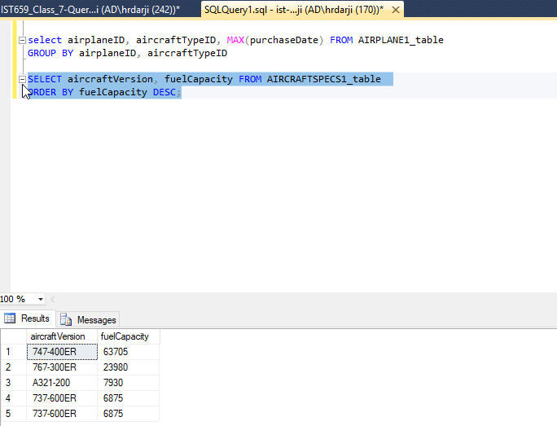

1. Find all airplanes which flew in the first half of Feb 2014 (From Feb 1- to Feb 14) and the flight status was “on time”. Show airplane ID, purchase date, flight number, and status ID.

**SQL QUERY:**

SELECT FLIGHTSCHEDULE12_table.airplaneID, FLIGHTSCHEDULE12_table.flightNumber, FLIGHTSCHEDULE12_table.statusID,

AIRPLANE1_table.purchaseDate

FROM FLIGHTSCHEDULE12_table

LEFT JOIN AIRPLANE1_table

ON FLIGHTSCHEDULE12_table.airplaneID=AIRPLANE1_table.airplaneID

where flightDate between '2014-02-01 00:00:00.000' AND '2014-02-14 00:00:00.000'

AND statusID='O';

**SCREENSHOT:**

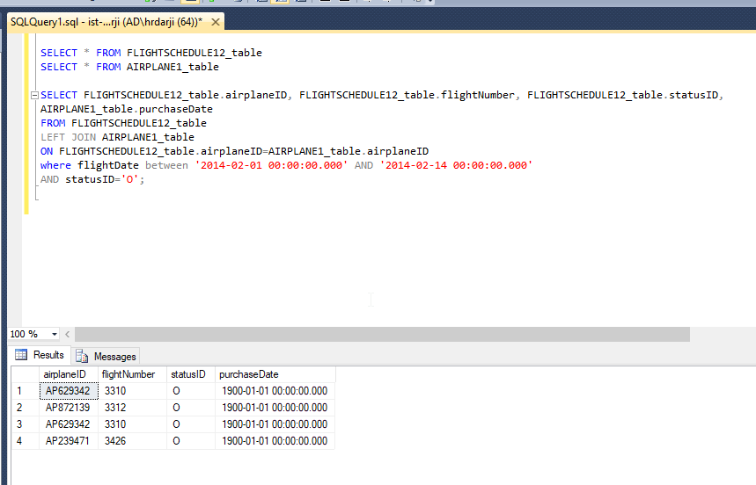

1. Find all flights which depart from “BOS” after noon. Show flight number, flight date, depart airport and scheduled depart time.

**SQL QUERY:**

SELECT * FROM FLIGHTSCHEDULE12_table

SELECT FLIGHTS_ROUTE1_table.flightNumber ,FLIGHTS_ROUTE1_table.departAirport,FLIGHTS_ROUTE1_table.scheduledDepartTime,

FLIGHTSCHEDULE12_table.flightDate

from FLIGHTS_ROUTE1_table

LEFT JOIN FLIGHTSCHEDULE12_table

ON FLIGHTS_ROUTE1_table.flightNumber=FLIGHTSCHEDULE12_table.flightNumber

WHERE FLIGHTS_ROUTE1_table.departAirport='BOS'

AND FLIGHTS_ROUTE1_table.scheduledDepartTime>'12:00:00.0000000';

**SCREENSHOT:**

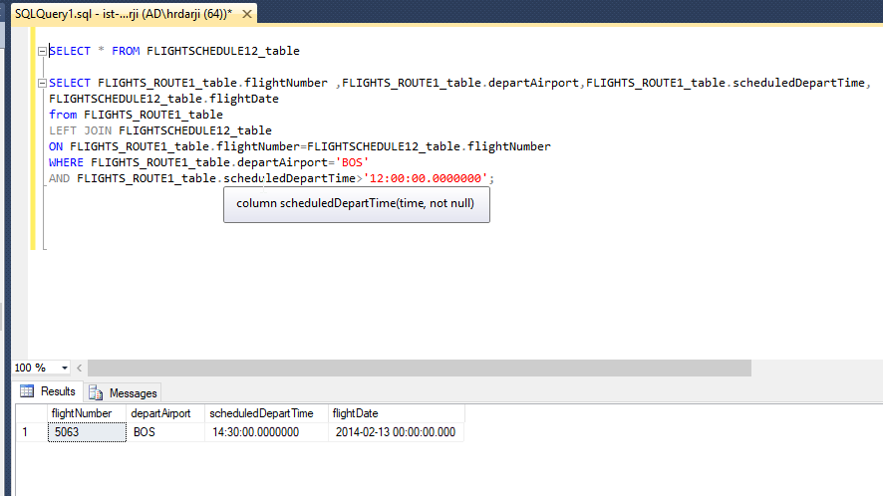

1. Find all airplanes which were delayed or cancelled. Show only airplane ID, flight date and status description.

**SQL QUERY:**

select * from FLIGHTSTATUS2_table

select * from FLIGHTSCHEDULE12_table

SELECT FLIGHTSCHEDULE12_table.airplaneID,FLIGHTSCHEDULE12_table.flightDate,

FLIGHTSTATUS2_table.description

from FLIGHTSCHEDULE12_table

LEFT JOIN FLIGHTSTATUS2_table

ON FLIGHTSCHEDULE12_table.statusID = FLIGHTSTATUS2_table.statusID

WHERE FLIGHTSCHEDULE12_table.statusID='D' OR FLIGHTSCHEDULE12_table.statusID='C';

**SCREENSHOT:**

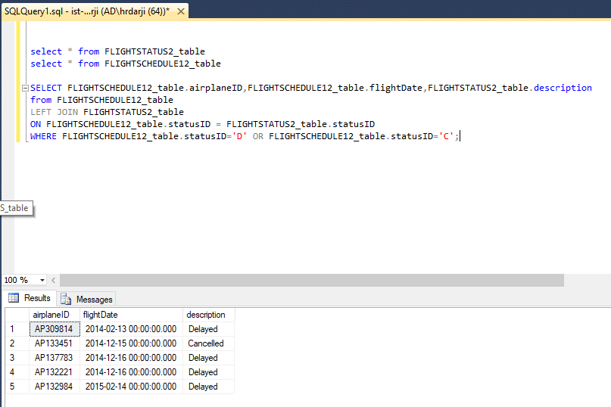

1. Find the flight(s) which are “on time”, display the Flight number and departure airport

**SQL QUERY:**

SELECT FLIGHTSCHEDULE12_table.flightNumber, FLIGHTS_ROUTE1_table.departAirport

from FLIGHTSCHEDULE12_table

LEFT JOIN FLIGHTS_ROUTE1_table

ON FLIGHTSCHEDULE12_table.flightNumber=FLIGHTS_ROUTE1_table.flightNumber

WHERE FLIGHTSCHEDULE12_table.statusID='O'

**SCREENSHOT:**

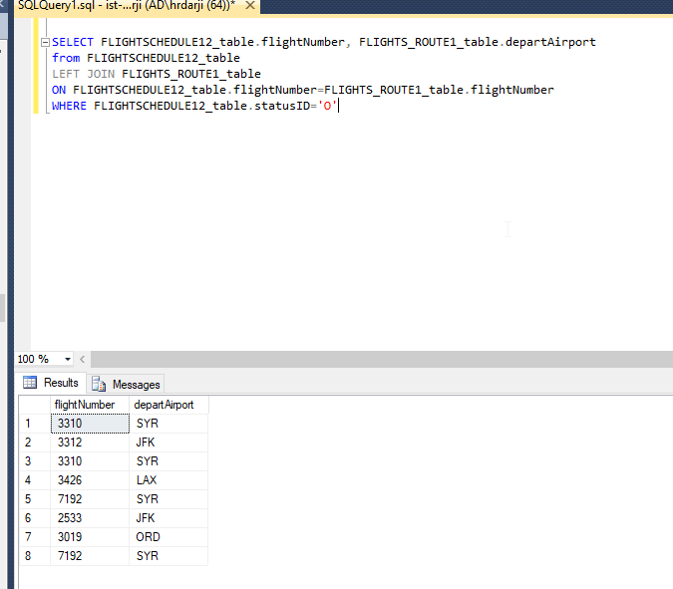

j.)Find all the airplanes that have not been scheduled to fly. *(You can use Left Join)*

**SQL QUERY:**

select DISTINCT airplaneID from FLIGHTSCHEDULE12_table

left join FLIGHTS_ROUTE1_table

on FLIGHTSCHEDULE12_table.flightNumber NOT IN ( FLIGHTS_ROUTE1_table.flightNumber)

**SCREENSHOT:**

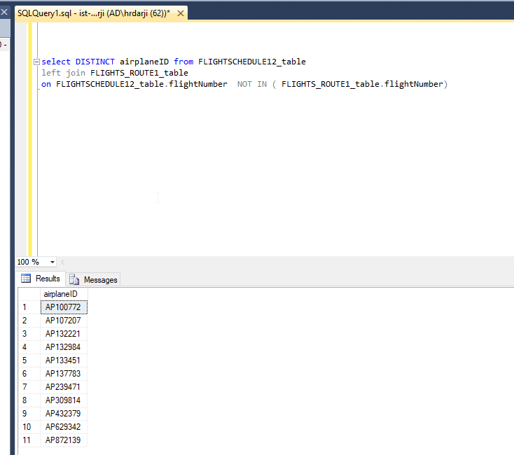

k.)Find all only airplanes that have been scheduled to fly and delayed. Display Airplane ID of the flight *(Use Right Join)*

**SQL QUERY:**

select DISTINCT airplaneID from FLIGHTSCHEDULE12_table

right join FLIGHTS_ROUTE1_table

on FLIGHTS_ROUTE1_table.flightNumber IN (FLIGHTSCHEDULE12_table.flightNumber)

where statusID='D'

**SCREENSHOT:**

